

**16//50 Soi Sophon (Sukhumvit 68) Sukhumvit Rd. Bangna Bangkok 10260**

[**http://peepimplaceapartment.weebly.com**](http://peepimplaceapartment.weebly.com)

**โทร. 081-831-2226, 081-802-2599**

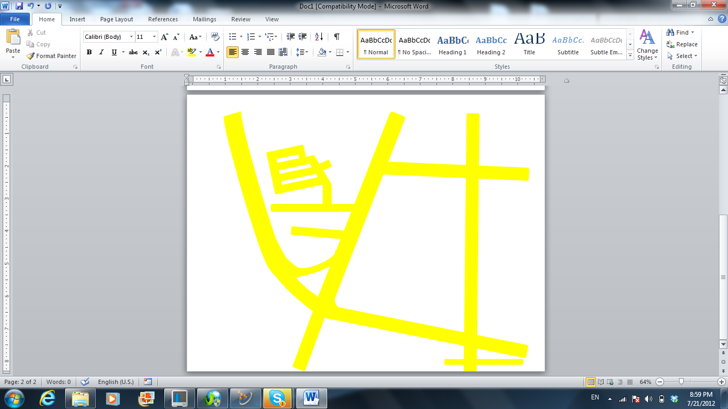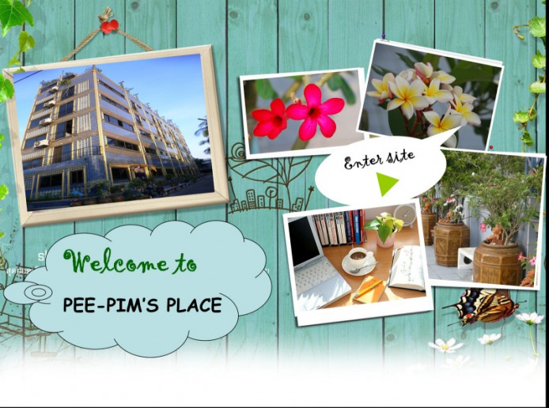

**Soi 1**

**Kualnamthai 2**

**Bangna-Trad Rd.**

**Sukhumvit 68**

**สี่แยกบางนา**



**Soi Udom Suk (Sukhumvit 103)**

**Bangna Express way**

**Sukhumvit 72**



**Sukhumvit Rd.**

**Go to Samrong**



**Suan Luang Rama 9**

**Go to Chonburi/ Pattaya/**

**Suwannabhumi Airport**

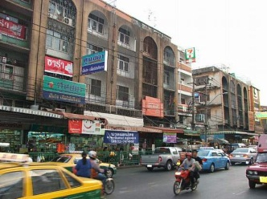

**Udom Suk market**

**E12 UDOM SUK**

**PEE-PIM’S PLACE**

**Go to Prakanong/ Onnut**

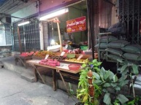

**Bangna Intersection market**



**SENSE**



**Srinagarin Rd.**

**รินทร์**



**Siang Son Niwet Village**

**Soi 4**

**Soi 3**

**Soi 5**

http://www.thaihometown.com/property-express/image_file/18786/18786-1.jpghttp://www.istockphoto.com/file_thumbview_approve/5054550/2/istockphoto_5054550-evergreen-tree-illustration.jpg

**Soi 2**

**Bangna Intersection**

**Sanphawot Rd.**

**ถนนสรรพาวุธ**